**RAVFS**

**Req’d Services**

**Use Case Report**

Revision History

|  |  |  |  |  |
| --- | --- | --- | --- | --- |
| **Authors** | **Description of Change** | **Sections** | **Rev** | **Date** |
| Everyone | Add names | 1 | 1 | 1/28/19 |
| Samantha | Add Use Case Diagram | 2.1 | 2 | 2/4/19 |
| Everyone | Filled use cases | 2.2 | 3 | 2/13/19 |
| Everyone | Changed account creation process and Linking | 2.2 | 4 | 2/18/19 |
| Samantha | Updated use case diagram | 2.1 | 5 | 2/18/19 |

**2 Project Description** **4**

2.1 Use Case Diagram 4

2.2 Use Case List 5

2.2.1 Tenant - View Own Requests 6

2.2.1.1 The tenant has made previous service requests and/or has active requests. 6

2.2.1.2 The tenant has made no requests. 6

2.2.2 Tenant - Request Service 6

2.2.2.1 Request non-emergency service 7

2.2.2.2 Request emergency service 7

2.2.2.3 User account is not linked 7

2.2.3 Tenant - Cancel Request 7

2.2.3.1 Cancel service request 7

2.2.4 Service Provider - Service Dispatch 7

2.2.4.1 Respond to non-emergency service 7

2.2.4.2 Respond to emergency service 7

2.2.5 Service Provider - Create Claim 8

2.2.5.1 Create a claim 8

2.2.6 Landlord - View Requests 8

2.2.6.1 View only active service requests. 8

2.2.6.2 View all previous and current service requests. 8

2.2.7 Landlord - accept/deny claims 8

2.2.7.1 Accept request 8

2.2.7.2 Deny request 8

2.2.8 Landlord - Pay Claim 9

2.2.9 Create an Account 9

2.2.9.1 Add a Service Provider 9

2.2.9.2 Add a Tenant Account 9

2.2.9.3 Add a Landlord Account 9

2.2.10 Landlord - Remove Link 9

2.2.10.1 Unlink an account 9

2.2.11 Landlord - Update User 10

2.2.11.1 Updates Tenant 10

2.2.11.2 Updates Service provider 10

2.2.12 Landlord - View User Request History 10

2.2.12.1 The tenant has made requests. 10

2.2.12.2 The tenant has made no requests. 10

2.2.12.3 There are no linked tenants 10

2.2.13 Link Account 10

2.2.13.2 Link tenant account 11

2.2.14 Update Account 11

2.2.14.1 User is Landlord 11

2.2.14.2 User is Tenant 11

2.2.14.3 User is Service Provider 11

2.2.14.4 User is updating general information 11

**1 Team Description**

|  |  |
| --- | --- |
| **Team Member Name** | **Email Address** |
| Samantha Montoya | sammontoya@csu.fullerton.edu |
| Rene Ortiz | ror5446@csu.fullerton.edu |
| Anthony Goossens | yorkii@csu.fullerton.edu |
| Francisco Daniel | fpdaniel2@csu.fullerton.edu |
| Vincent Bravinder | bravinderv@csu.fullerton.edu |

# **2 Project Description**

Statement of Purpose:

Provide automation platform for a tenant landlord interaction, particularly in regards to tenants requesting services from maintenance providers.

Detailed Description:

A platform that allows for tenants to request a service provider, they will be asked what kind of service they need and then a series of questions that categorizes the urgency of the request. Landlords will be able to look at requests at their leisure, and can approve or deny the request. If a request is denied the tenant will need to pay for the service.

The platform will also contact the appropriate service provider, if the request is an emergency, or the landlord has approved the request. The service provider can insert a claim showing cost of service. The landlord will be able to pay this claim, or direct the tenant to pay the claim.

## **2.1 Use Case Diagram**

<https://www.lucidchart.com/invitations/accept/a3e2e307-ffa0-4cc1-bfab-7c54b5df6575>

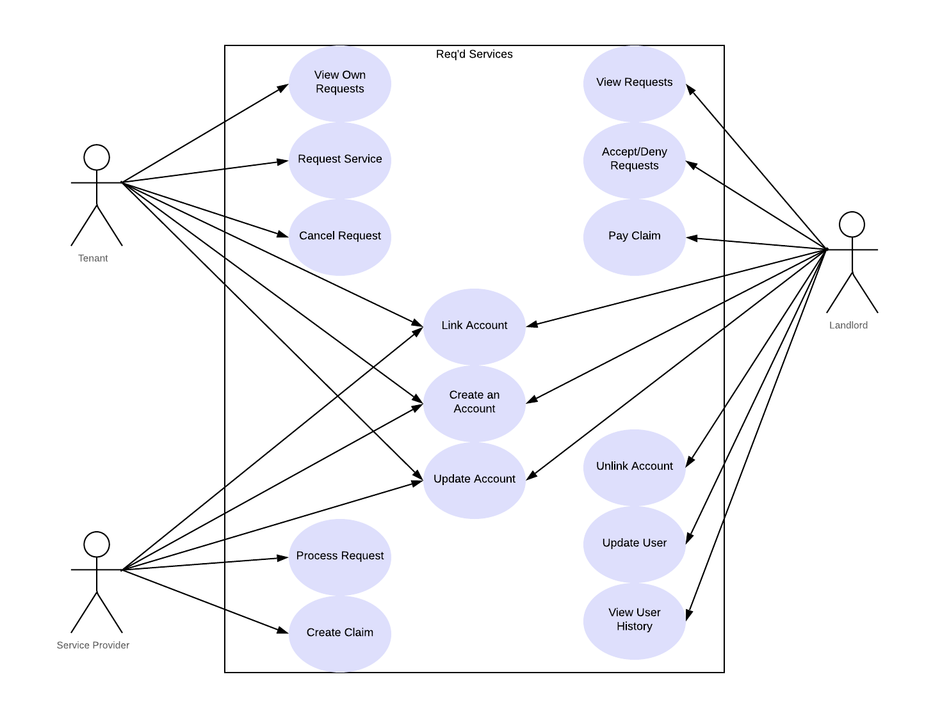

## **2.2 Use Case List**

Flow of the program should help with scenarios of use cases:

<https://www.lucidchart.com/invitations/accept/b896485b-d59a-4c46-8d3e-85c378563a91>

|  |  |  |
| --- | --- | --- |
| **Use Case** | | |
| **Sequence Number** | **Actor** | **Goal** |
| 1 | Tenant | View Own Requests |
| 2 | Tenant | Request Service |
| 3 | Tenant | Cancel Request |
| 4 | Service Provider | Process Request |
| 5 | Service Provider | Create Claim |
| 6 | Landlord | View Requests |
| 7 | Landlord | Accept/Deny Claims |
| 8 | Landlord | Pay Claim |
| 9 | Tenant, Service Provider, Landlord | Create an Account |
| 10 | Landlord | Remove Link |
| 11 | Landlord | Update User |
| 12 | Landlord | View User Request History |
| 13 | Service Provider, Tenant, Landlord | Link Account |
| 14 | Service Provider, Tenant, Landlord | Update Account |

### **2.2.1 Tena**nt - View Own Requests

Primary Actor: Tenant

Secondary Actors(s):

Goal in Context: Allow a tenant to view their own service requests.

Preconditions: The tenant needs to have an account.

Additional Description:

#### **2.2.1.1 The tenant has made previous service requests and/or has active requests.**

A list of previous and current service requests is displayed with the most recent requests displayed first.

#### **2.2.1.2 The tenant has made no requests.**

A statement is displayed that states that the tenant has made no requests.

### **2.2.**2 **T**enant - Request Service

Primary Actor: Tenant

Secondary Actors(s):

Goal in Context: To request a service to be done to their home.

Preconditions: Tenant needs to have an account

Additional Description:

#### **2.2.2.1 Request non-emergency service**

Request a service to be done that is not an emergency service. Ex. new paint for the walls of the home. Dishwasher maintenance.

#### **2.2.2.2 Request emergency service**

Request for a service that needs to be done right away. Ex. no water, new carpet after a flood.

#### **2.2.2.3 User account is not linked**

Tell user to request an invitation from their landlord. Then goes to previous 2 scenarios.

### 2.2.3 Tenant - Cancel Request

Primary Actor: Tenant

Secondary Actors(s):

Goal in Context: To cancel a request that has already been made.

Preconditions: Have a pending request

Additional Description:

#### **2.2.3.1 Cancel service request**

Cancel a requested service:. Ex. a request was made by mistake.

### 2.2.4 Service Provider - Service Dispatch

Primary Actor: Service provider

Secondary Actors(s): Tenant, landlord

Goal in Context: Process a service request

Preconditions: Received service request

Additional Description:

#### **2.2.4.1 Respond to non-emergency service**

Schedule a date to provide the requested service.

#### **2.2.4.2 Respond to emergency service**

Acknowledge and respond to provide the necessary service.

### 2.2.5 Service Provider - Create Claim

Primary Actor: Service provider

Secondary Actors(s): Tenant, landlord

Goal in Context: Create claim for providing service

Preconditions: Service Dispatch completed

Additional Description:

#### **2.2.5.1 Create a claim**

Create a claim for the provided service to send to landlord.

### 2.2.6 Landlord - View Requests

Primary Actor: Landlord

Secondary Actors(s):

Goal in Context: View previous and/or active service requests from tenants.

Preconditions: Needs an account

Additional Description: This can be used to view current, previous, or all requests.

#### **2.2.6.1 View only active service requests.**

Show a list of current service requests from tenants.

#### **2.2.6.2 View all previous and current service requests.**

Show a list of all previous and current service requests with the most recent service requests listed first.

### 2.2.7 Landlord - accept/deny Request

Primary Actor: Landlord

Secondary Actors(s):

Goal in Context: the landlord accepts or denies a request made by the tenant

Preconditions: tenant made a service request claim

Additional Description:

#### **2.2.7.1 Accept request**

Accepts the request made by the tenant. Ex. Tenants service request is legitimate.

#### **2.2.7.2 Deny request**

Deny the request made by the tenant. Ex. Tenants service request is illegitimate or something that the landlord believed did not need to be done

### 2.2.8 Landlord - Pay Claim

Primary Actor: Landlord

Secondary Actors(s):

Goal in Context: Allows for the landlord to mark a payment as complete.

Preconditions: Service provider needs to create a claim

Additional Description:

**2.2.8.1 Mark as paid**

Marks a claim as paid. Able to put amount that has been paid.

### 2.2.9 Create an Account

Primary Actor: Tenant, Service Provider, Landlord

Secondary Actors(s):

Goal in Context: Add a tenant, maintenance provider, or landlord account

Preconditions: Want to create an account and have an email address

Additional Description:

#### **2.2.9.1 Add a Service Provider**

Add a user with the profile of service provider, add their name and contact information, and be able to choose which services they can take care of.

#### **2.2.9.2 Add a Tenant Account**

Add a user with the profile of tenant. Add their name and contact information as well as their address where services would be rendered.

#### **2.2.9.3 Add a Landlord Account**

Add a user with the profile of Landlord. Add their name and contact information as well as a landlord tag they can be searched for.

### 2.2.10 Landlord - Remove Link

Primary Actor: Landlord

Secondary Actors(s):

Goal in Context: Remove a tenant or maintenance provider from their link.

Preconditions: An account to unlink

Additional Description:

#### **2.2.10.1 Unlink an account**

Landlord no longer uses that service provider or has to manage that tenant. Used mainly for removing the ability to get requests/claims from that account.

### 2.2.11 Landlord - Update User

Primary Actor: Landlord

Secondary Actors(s):

Goal in Context: Change information about a tenant or maintenance provider.

Preconditions: An account needing updated is required

Additional Description:

#### **2.2.11.1 Updates Tenant**

Landlord updates tenant information such as name, phone number, ect.

#### **2.2.11.2 Updates Service provider**

Landlord updates Service Provider information such as name, phone number, ect.

### 2.2.12 Landlord - View User Request History

Primary Actor: Landlord

Secondary Actors(s):

Goal in Context: View the history of maintenance requests for an individual user.

Preconditions: Logged into a landlord account

Additional Description:

#### **2.2.12.1 The tenant has made requests.**

A list of all previous and current service requests is displayed with the most recent requests listed first.

#### **2.2.12.2 The tenant has made no requests.**

A statement is displayed that says that the tenant has made no service requests.

#### **2.2.12.3 There are no linked tenants**

A statement is displayed that says that there are no linked tenants, and that they should link some.

### 2.2.13 Link Account

Primary Actor: Landlord

Secondary Actors(s): Service Provider, Tenant

Goal in Context: Account information is handled

Preconditions: User has been added

Additional Description:

**2.2.13.1 Link service provider account**

The landlord gives a service provider a code to be able to link service information

#### **2.2.13.2 Link tenant account**

The landlord gives a tenant a code to be able to input to join the community.

### 2.2.14 Update Account

Primary Actor: Tenant, Landlord, Service provider

Secondary Actors(s):

Goal in Context: Users are able to change information pertaining to their account.

Preconditions: User account exists and they are allowed to edit it. They are logged in.

Additional Description:

#### **2.2.14.1 User is Landlord**

Landlord updates their specific account information Ex. Office Hours

#### **2.2.14.2 User is Tenant**

Tenant updates their specific account information. Ex. apartment number

#### **2.2.14.3 User is Service Provider**

Service provider updates their own account information. Ex Services they provide.

#### **2.2.14.4 User is updating general information**

User can change general information about their account. Ex password, name, contact information, email etc.